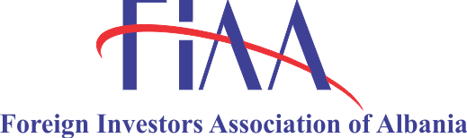

**DIGITAL HORIZON ALBANIA 2025**

*Connecting Albania's Future: Technology as the Engine of Economic Growth*

**November 5th, 2025 @Tirana Marriott Hotel**

**DRAFT AGENDA**

**09:30 – 10:00 Welcoming Remarks**

Welcome from the Organizers

Opening Keynote: "The Digital Pulse of the Nation", by **Balazs Revesz**, President of FIAA

EU Digital Agenda and Growth Plan for Albania (EU Delegation and EU Commission) tbc

Greetings by **Delina Ibrahimaj**, Ministerof Economy and Innovation

**10:00 – 10:30 Innovation from the Edge: Global & Regional Insights**

*The Blueprint for a Digital Nation: Lessons from the World's Best Featuring our Global and Regional Keynote Speaker*

**Speaker:** **Anne o’Leary**, VP of Mid-Market EMEA META/Ex Vodafone CEO Irland (tbc)

**10:30 – 11:30 Panel 1 – The Engine Room: How a Healthy Tech Sector Fuels the Success of Smart Nations**

*This panel reframes the success stories to highlight the ecosystem technology enables for the country.*

**Moderator**: tbc

**Panelists**: TP (tbc)

Banking representative (tbc)

Startup community (tbc)

RITECH (tbc)

Intracom Telecom Albania S.A (tbc)

Engineering Albania (tbc)

**12:00 - 13:00 Panel 2 – Upskilling in Albania in the Age of AI**

*This panel focuses on the urgent need to bridge the digital skills gap, to showcase initiatives and partnerships and to display how AI creates new job opportunities.*

**Moderator:** tbc

**Panelists**: International speaker (tbc)

Representative from the Ministry of Education of Albania (tbc)

Successful Albanian tech entrepreneur who benefited from upskilling initiatives (tbc)

**14:00 – 15:00 Panel 3 – Approaching new ICT companies – Pitching for Albania**

**Moderator:** tbc

**Panelists:** **Elira Kokona**, Executive Director, Albanian Investment Corporation

TechnoPark (tbc)

Plug & Play (tbc)

Fintech (tbc)

**15:00 – 16:00 Matchmaking Between Companies (New & Existing)**

*This session aims to fostering collaboration, investment, and innovation by bringing together emerging businesses and established companies to explore strategic partnerships that drive growth, competitiveness, and sustainable development.*

**16:00 Closing Keynote: "The Connected Decade: A Pact for Albania's Prosperity"**

**Final Reflections**: Synthesizing the day's lessons on sector health, innovation, and skills.